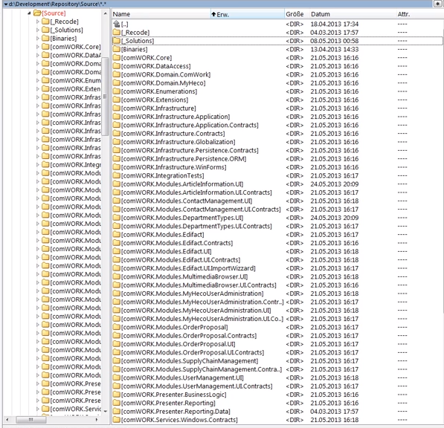

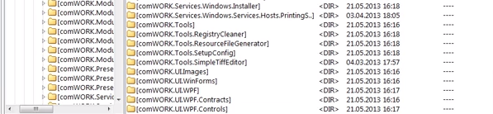

WPF Enterprise MVVM Session 2:

Adding Data and Business Layers using Entity Framework

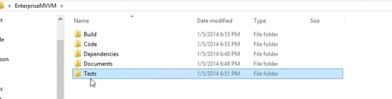

<https://www.youtube.com/watch?v=CpVNMmefvDo>